Extending Completion Optimization to RTL Designs Through
Contextual Partially Defined Boolean Functions
Master Draft v1.0

Abstract
Completion Optimization improves logic implementations by selecting favorable fully defined Boolean functions from the legal completions of a partially defined Boolean function (PDBF). A natural limitation appears to be that ordinary RTL blocks are usually regarded as completely specified. This paper demonstrates the feasibility of extending Completion Optimization to ordinary RTL designs through contextual PDBF extraction. The central observation is that an internal RTL block may be completely specified in isolation while only a subset of its local input terms is reachable within the complete design. The unreachable local terms become hidden contextual don't-care conditions. A prototype extraction procedure is demonstrated using a Vedic multiplier. The case study introduces independent and correlated reachability, constructs Contextual PDBFs for internal adder blocks, and reuses optimized implementations through a PDBF Passport Library. Measured results for arithmetic blocks from 2×2+2×2 through 12×12+12×12 products show gate-count reductions of up to 55.0% and logic-level reductions of up to 75.4% relative to conventional ripple-adder baselines. The results establish a new research direction in which synthesis first discovers the contextual PDBF, then optimizes the PDBF, and finally optimizes the circuit.

I. Introduction
Logic synthesis traditionally transforms a Boolean specification into an efficient gate-level implementation. Recent work on Completion Optimization demonstrated that significant improvements in logic area and depth can be achieved by optimizing an incompletely specified Boolean function before logic synthesis. This observation led to a new synthesis principle:
First Optimize the Boolean Function.
Then Optimize the Circuit.
Experimental results have shown that Completion Optimization, combined with the PDBF Passport Library, can produce substantially more efficient implementations for benchmark functions and arithmetic circuits.
Despite these promising results, an important question remains. Conventional RTL designs are generally regarded as completely specified Boolean functions, whereas Completion Optimization operates on partially defined Boolean functions. Consequently, the applicability of Completion Optimization to ordinary RTL designs is not immediately apparent.
The central observation of this work is that an internal RTL block is completely specified only when viewed in isolation. Within the context of the complete design, it often behaves as a partially specified Boolean function because many local input terms are unreachable. Those unreachable terms are prevented by the behavior of the surrounding circuitry and therefore cannot influence the externally observable behavior of the complete design.
This observation suggests that internal RTL blocks may be represented as Contextual Partially Defined Boolean Functions (Contextual PDBFs), whose specified terms are determined by the reachable behavior of the complete design rather than by the complete local truth table.
This paper demonstrates the feasibility of a new methodology for extending Completion Optimization to ordinary RTL designs through contextual PDBF extraction. Rather than presenting a universal extraction algorithm, the objective is to establish a new research direction by demonstrating that hidden contextual don't-care conditions can be revealed automatically and exploited for Boolean optimization before conventional logic synthesis begins.
The proposed methodology is demonstrated using a prototype implementation applied to a Vedic multiplier. The extracted Contextual PDBFs are optimized using Completion Optimization and implemented through the PDBF Passport Library. The results confirm the feasibility of the approach and illustrate its potential for extending Completion Optimization to conventional RTL synthesis.
The principal contributions of this work are:
• the identification of hidden contextual don't-care conditions in ordinary RTL designs;
• the definition of a Contextual PDBF based on reachable local input terms;
• a PDBF extraction procedure demonstrated by a prototype implementation;
• the classification of independent and correlated reachability;
• integration of Contextual PDBFs with Completion Optimization and the PDBF Passport Library; and
• experimental evidence showing substantial reductions in gates and logic depth.

II. Background

A. Partially Defined Boolean Functions
A Partially Defined Boolean Function specifies required output values only for a subset of its input terms. The remaining terms are unspecified and may be assigned values without violating the original specification. Each legal assignment of the unspecified terms produces a Fully Defined Boolean Function, referred to as a Legal Completion.
The set of all Legal Completions forms an Opportunity Space. Different completions can produce circuit implementations with substantially different area, depth, fan-out, and wiring characteristics even though every completion satisfies the same partial specification.

B. Completion Optimization
Completion Optimization searches the Opportunity Space of a PDBF and selects a Legal Completion according to an implementation objective. The selected Fully Defined Boolean Function is then optimized by conventional synthesis tools. Completion Optimization therefore operates at the Boolean-function level, while conventional synthesis optimizes the implementation of the selected function.

C. PDBF Passport Library
A PDBF Passport records the identity and structure of a PDBF together with one or more optimized implementations and their measured characteristics. Typical Passport fields include gate count, logic levels, wire count, maximum gate fan-out, maximum input fan-out, and the optimization objective used to obtain the implementation.
The PDBF Passport Library allows previously optimized Contextual PDBFs to be recognized and reused. This creates a practical link between extraction, Boolean-function optimization, and implementation selection.

III. Hidden Don't-Care Conditions in RTL Designs
Completion Optimization optimizes incompletely specified Boolean functions. At first glance, this appears to limit its applicability because RTL descriptions are generally regarded as completely specified.
This perception results from considering each RTL block in isolation. In a complete design, the local inputs of an internal block are generated by preceding logic. Although the block's local specification may define an output for every possible input term, the surrounding circuitry may prevent many of those terms from ever occurring.
Consequently, only a subset of the complete local input space is reachable. The remaining local input terms are never exercised and cannot affect any primary output or architectural state under the considered operating context.
These unreachable local input terms therefore represent hidden contextual don't-care conditions. They are not inserted arbitrarily and are not supplied by the designer. They are revealed by the behavior of the complete RTL design.
Although an RTL block may be completely specified in isolation, it often becomes only partially specified within the context of the complete design because many local input terms are unreachable.

IV. Contextual Partially Defined Boolean Functions
The hidden contextual don't-care conditions described above allow an internal RTL block to be represented as a partially defined Boolean function.
Definition 1 (Contextual PDBF). A Contextual Partially Defined Boolean Function of an RTL block is obtained by preserving only those local input terms that are reachable under assignments of the primary inputs of the complete RTL design. All remaining local input terms are treated as unspecified.
Unlike conventional incompletely specified Boolean functions, the unspecified terms are not supplied explicitly by the designer. Instead, they are discovered from the complete design context.
The resulting Contextual PDBF remains behaviorally equivalent to the original RTL block within the context of the complete design. It preserves every reachable local input/output relation while exposing additional optimization opportunities on unreachable terms.
Contextual-equivalence principle. Replacing an internal block by any implementation that agrees with the original block on every reachable local input term preserves the observable behavior of the complete design under the same operating context.

V. PDBF Extraction Procedure
The Contextual PDBF of an RTL block may be obtained by observing the behavior of the complete RTL design and recording the local input terms that occur during operation.
The objective of this work is not to present a universal extraction algorithm applicable to arbitrary RTL designs. Rather, the objective is to demonstrate that Contextual PDBFs can be extracted automatically from ordinary RTL descriptions.
To demonstrate feasibility, a prototype implementation of the extraction procedure was developed for the Vedic multiplier case study.
1. Select an RTL block for optimization.
2. Enumerate the assignments of the primary inputs of the complete RTL design.
3. Evaluate the complete RTL design for each assignment.
4. Record all reachable local input terms of the selected RTL block.
5. Remove duplicate local input terms.
6. Construct the Contextual PDBF by preserving the unique reachable terms and treating all remaining local terms as unspecified.
The unique reachable local input terms define the specified portion of the Contextual PDBF, while all remaining local input terms become hidden contextual don't-care conditions.
This procedure states what must be determined without prescribing a universal implementation. Exhaustive evaluation is suitable for the representative case study used in this paper. Larger designs may employ symbolic simulation, SAT, BDDs, formal reachability analysis, or other methods.

VI. Vedic Multiplier Case Study
The proposed methodology was evaluated using a Vedic multiplier architecture composed of four multiplier blocks, M0–M3, and three adder blocks, A0–A2. The multiplier blocks generate partial products, and the adders combine those partial products to produce the final product.
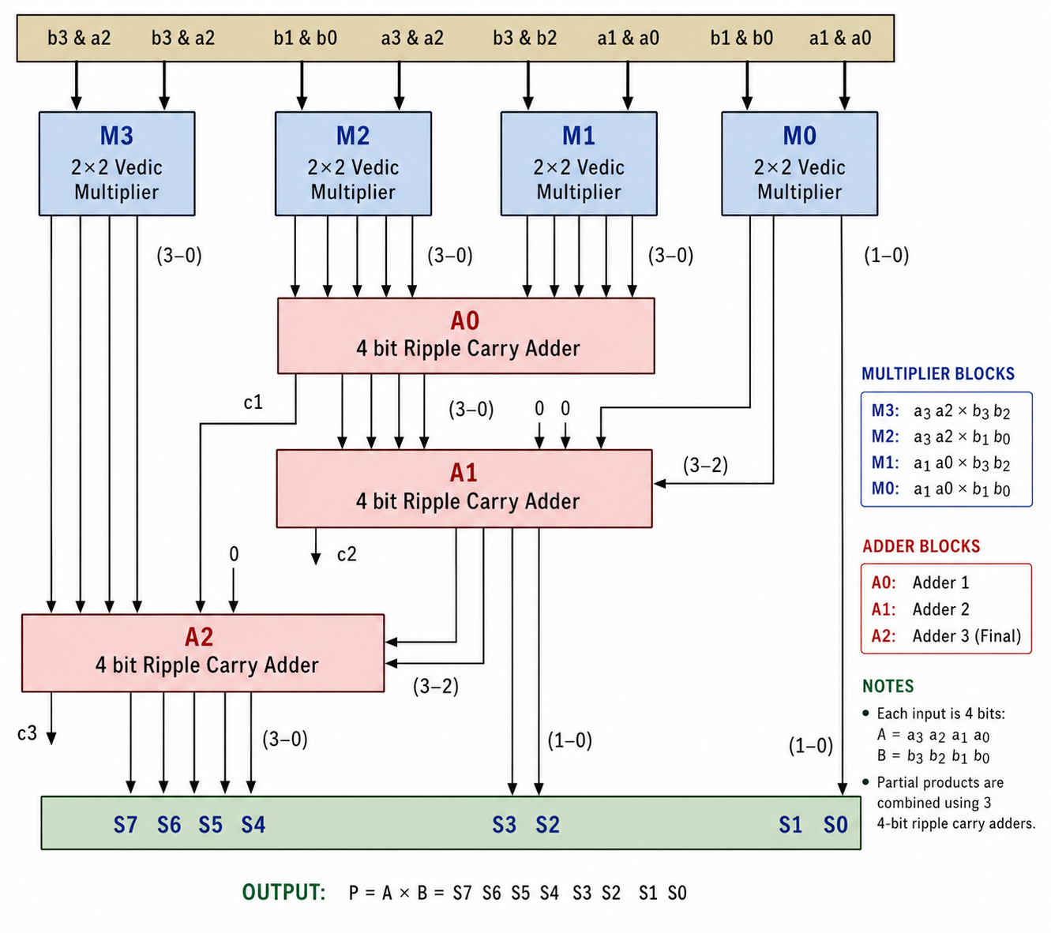
Fig. 1. Vedic multiplier structure used for Contextual PDBF extraction.
Each adder was analyzed independently. For every assignment of the multiplier primary inputs, the complete design was evaluated and the local input term applied to the selected adder was recorded. Duplicate terms were removed to obtain the reachable local input set.
The case study demonstrates two forms of reachability. Block A0 illustrates Independent Reachability, in which upstream values can be combined independently. Blocks A1 and A2 illustrate Correlated Reachability, in which values that are separately reachable cannot necessarily occur together.
The same extraction concept was subsequently applied to a family of arithmetic blocks corresponding to the addition of two multiplier products, ranging from 2×2+2×2 through 12×12+12×12 products. These Contextual PDBFs were optimized and stored in the PDBF Passport Library.

VII. Independent Reachability
Block A0 receives local inputs generated by multiplier blocks M2 and M3. In the selected architecture, these blocks depend on disjoint subsets of the primary multiplier inputs. Their reachable output values can therefore vary independently.
If each 2×2 multiplier produces seven distinct reachable output terms, every reachable output of M2 can occur together with every reachable output of M3. The reachable local input set of A0 is therefore the Cartesian product of the two reachable output sets:
|R(A0)| = |R(M2)| × |R(M3)| = 7 × 7 = 49.
The extraction procedure consequently identifies 49 distinct reachable local input terms for A0. These terms form the specified portion of the Contextual PDBF. All other local input combinations are unreachable within the complete multiplier and become hidden contextual don't-care conditions.
Independent Reachability. The reachable local input space of a block exhibits Independent Reachability when the relevant upstream values depend on independent subsets of primary inputs and may therefore be combined by a Cartesian product.

VIII. Correlated Reachability
Not all internal blocks exhibit Independent Reachability. A different situation arises when multiple local inputs originate from logic that depends on common primary input variables.
Block A1 receives inputs from the output of A0 and from multiplier block M0. Although values at the A0 output and the M0 output may each be reachable individually, they cannot necessarily occur together because they are generated from overlapping primary-input information.
For example, when the complete multiplier input is 11111111, A0 produces the sum 101+101=1010. For that global input, the related M0 value is uniquely determined. The A0 output value cannot be combined with every independently reachable M0 value. Such combinations would be locally plausible but globally unreachable.
Instead, the reachable local input terms are determined directly from the behavior of the complete RTL design. During the extraction procedure, every assignment of the primary multiplier inputs is evaluated and the corresponding local input terms of A1 are recorded. The unique reachable local input terms define the specified portion of the Contextual PDBF, while all remaining local input terms become hidden contextual don't-care conditions.
The same principle applies to A2. Its inputs are generated after additional computation stages, and the accumulated dependencies further constrain the reachable local input space.
Correlated Reachability. The reachable local input space of a block exhibits Correlated Reachability when upstream values share dependencies and therefore cannot be combined independently. The reachable terms must be projected from the behavior of the complete design.
Correlated Reachability is particularly important because it may produce far fewer reachable local input terms than an analysis based only on the individually reachable values of each incoming signal.

IX. Integration with Completion Optimization
After a Contextual PDBF has been extracted, it is processed by the existing Completion Optimization framework without changing the original optimization principle. Completion Optimization assigns values to the contextual don't-care terms and selects a Legal Completion according to the desired implementation objective.
The selected completion is then synthesized or retrieved from the PDBF Passport Library. Conventional optimization may subsequently be applied to the resulting fully defined Boolean function.
The complete methodology therefore consists of three successive stages:
First Discover the Contextual PDBF.
Then Optimize the PDBF.
Then Optimize the Circuit.
The first stage reveals optimization opportunities that remain hidden when a block is considered only through its complete local truth table. The second stage searches the Legal Completions of the extracted PDBF. The third stage optimizes the implementation of the selected completion.

X. Experimental Results
The proposed methodology was evaluated using Contextual PDBFs derived from internal arithmetic blocks. The experimental study confirmed both forms of contextual reachability. A0 exhibited Independent Reachability, while A1 and A2 exhibited Correlated Reachability.
The extracted Contextual PDBFs were optimized using Completion Optimization and implemented through the PDBF Passport Library. The resulting implementations were compared with conventional area-oriented ripple adders and faster ripple adders.
TABLE I
SUMMARY OF MEASURED RESULTS
Multiplier pair | Area ripple  gates / levels | Faster ripple  gates / levels | GT gates /  levels | GT wires | Max gate  fan-out | Max input  fan-out
2×2 + 2×2 products | 24 / 13 | 27 / 10 | 23 / 5 | 51 | 6 | 2
3×3 + 3×3 products | 80 / 45 | 91 / 34 | 41 / 14 | 89 | 9 | 2
4×4 + 4×4 products | 108 / 61 | 123 / 46 | 57 / 15 | 123 | 4 | 2
5×5 + 5×5 products | 136 / 77 | 155 / 58 | 72 / 21 | 155 | 6 | 2
6×6 + 6×6 products | 164 / 93 | 187 / 70 | 118 / 29 | 249 | 4 | 2
Table I summarizes the measured implementation characteristics. The GT implementations consistently reduce logic depth while maintaining compact gate counts. The largest gate reductions occur for the 3×3, 4×4, and 5×5 product-addition blocks.
TABLE II
IMPROVEMENT RELATIVE TO AREA-ORIENTED RIPPLE ADDERS
Case | Gate reduction | Level reduction
2×2 products | 4.2% | 61.5%
3×3 products | 48.8% | 68.9%
4×4 products | 47.2% | 75.4%
5×5 products | 47.1% | 72.7%
6×6 products | 28.0% | 68.8%
Relative to area-oriented ripple adders, logic-level reductions exceed 60% for every evaluated case and reach 75.4% for the 8×8 product-addition block. Gate-count reductions approach 50% for the 3×3, 4×4, and 5×5 cases.
TABLE III
IMPROVEMENT RELATIVE TO FASTER RIPPLE ADDERS
Case | Gate reduction | Level reduction
2×2 products | 14.8% | 50.0%
3×3 products | 55.0% | 58.8%
4×4 products | 53.7% | 67.4%
5×5 products | 53.5% | 63.8%
6×6 products | 36.9% | 58.6%
Relative to faster ripple adders, the GT implementations reduce gate count by 14.8% to 55.0% and logic depth by 50.0% to 67.4%.
The observed improvements originate from optimization opportunities exposed by the extracted Contextual PDBFs. By preserving only reachable local input terms and treating all other terms as hidden contextual don't-care conditions, Completion Optimization can select Boolean functions unavailable in the conventional fully specified representation.
The experimental results demonstrate that the principal source of the observed improvements is not a new implementation-level optimization algorithm, but the discovery of contextual optimization opportunities that remain hidden in conventional RTL representations.

XI. Discussion
The proposed methodology extends the applicability of Completion Optimization beyond explicitly incompletely specified Boolean functions. Ordinary RTL descriptions may contain internal blocks whose local truth tables are fully defined but whose complete local input spaces are not reachable in the surrounding design.
The Contextual PDBF captures the effective Boolean behavior of such a block. It does not alter any reachable behavior. Instead, it removes requirements on local terms that cannot occur in the complete design.
Independent Reachability and Correlated Reachability provide an initial classification of contextual relationships. Independent Reachability allows reachable sets to be composed from independent upstream values. Correlated Reachability requires projection from the behavior of the complete design because individually reachable values may not be jointly reachable.
A prototype extraction procedure was implemented for the Vedic multiplier case study to demonstrate the feasibility of contextual PDBF extraction. The objective is not to present a universal extraction algorithm, but to establish the practicality of the methodology and identify a promising new direction for logic synthesis research.
The extraction methodology is independent of the particular implementation used in the prototype. Exhaustive evaluation provides a clear demonstration for bounded examples. More scalable realizations may use symbolic simulation, SAT solving, BDDs, formal verification, compositional reachability, abstraction, or hybrid analysis.
The PDBF Passport Library offers a complementary path for reuse. Once a Contextual PDBF has been identified and optimized, its implementations and measured properties can be stored and reused when the same contextual function occurs in other designs.
The principal contribution of this work is therefore not a specific extraction algorithm, but the demonstration that Contextual PDBFs exist within ordinary RTL designs and can be exploited by Completion Optimization.

A. Future Research Directions
• symbolic and SAT-based extraction for large RTL designs;
• BDD and formal-reachability methods;
• automatic identification of promising internal blocks;
• hierarchical and compositional Contextual PDBFs;
• approximate conservative reachability analysis;
• automatic PDBF Passport matching and library growth;
• integration into native and commercial EDA flows;
• evaluation on industrial arithmetic, control, and datapath designs; and
• optimization objectives that include area, delay, power, fan-out, and wiring.
This work is intended to establish a research direction rather than present a complete RTL synthesis solution. It shows that another path exists: discover contextual partiality first, and then exploit it with Boolean-function optimization.

XII. Conclusion
This paper introduced Contextual Partially Defined Boolean Functions for ordinary RTL designs. The central observation is that an internal RTL block may be completely specified in isolation while only a subset of its local input terms is reachable within the complete design.
The unreachable terms form hidden contextual don't-care conditions. A PDBF extraction procedure was presented and demonstrated through a prototype applied to a Vedic multiplier. The case study introduced Independent Reachability and Correlated Reachability and showed how reachable local terms define the specified portion of a Contextual PDBF.
The extracted Contextual PDBFs were optimized using Completion Optimization and implemented through the PDBF Passport Library. Measured arithmetic results demonstrated substantial gate-count and logic-depth reductions relative to two conventional ripple-adder baselines.
These results demonstrate that incompletely specified Boolean functions need not be supplied explicitly by a designer. They can emerge from the context of ordinary RTL designs.
First Discover the Contextual PDBF.
Then Optimize the PDBF.
Then Optimize the Circuit.

References
[1] G. Toms, “Completion Optimization of Partially Defined Boolean Functions,” manuscript in preparation / submitted version.
[2] R. K. Brayton and A. Mishchenko, “ABC: An Academic Industrial-Strength Verification Tool,” in Proc. CAV, 2010.
[3] Reference on Vedic multiplier architectures to be added.
[4] Reference on reachability and Boolean don’t-care computation to be added.
[5] Reference on SAT/BDD-based symbolic analysis to be added.

